OUTPUT MONITORING GROUP

DRAFT OUTPUT MONITORING REPORT: Quarter 3 2015-16

1. Introduction
This document summarises what has been achieved for customers against Scottish Water’s Delivery Plan for the 2015-21 period and confirms the position up to the end of December 2015 (Quarter 3 2015/16). It has been prepared for the Output Monitoring Group (OMG) which was set up by Ministers to monitor and report on the delivery of their Objectives.

The OMG comprises the main stakeholders in Scotland’s water industry: Scottish Government, Scottish Water, Citizens Advice Scotland, Scottish Public Services Ombudsman and the regulators (the Water Industry Commission for Scotland, the Scottish Environment Protection Agency and the Drinking Water Quality Regulator). It is chaired by Scottish Government and operates under a Terms of Reference agreed by Ministers.

1.1 What We Monitor
Each quarter the OMG assesses Scottish Water’s progress with the delivery of outputs using a metric, Overall Measure of Delivery (OMD), to measure Scottish Water’s progress against targets agreed in its Delivery Plan.

Delivery progress is also monitored against the outputs agreed for individual programmes in Scottish Water's Delivery Plan, as shown in the following sections:

- Section 2: Providing continuous high quality drinking water (includes drinking water quality, reliability and security of supply).

- Section 3: Protecting and enhancing the environment (includes flood risk management).

- Section 4: Supporting economic development (includes climate change and improving the long term cost of service).

- Section 5: covers progress of projects due but not delivered by 31 March 2015.

A further set of outputs, including customer service measures, are reported annually at the end of each financial year.

Each section explains where a programme area is ahead or behind and, if behind, the remedial actions being taken by Scottish Water. The forecast year end status for each programme area has been measured against Scottish Water’s Delivery Plan 2015-21 target.

As noted at the OMG in September, targets are agreed with Ministers through Scottish Water’s Delivery Plan and reflect the year end position; the quarterly positions provided by Scottish Water enable progress towards those targets to be tracked.

1.2 Summary
The key points to report on Scottish Water’s output delivery in the period up to the end of December 2015 (Quarter 3 2015-16) are:

- The overall measure of delivery (OMD) position was 49.6 points in Quarter 3, an increase of 8.5 points from the Quarter 2 position of 41.1. The quarterly OMD position indicates that performance has been slower than anticipated but is forecast to recover and be within the target range at March 2016.

- Providing continuous high quality drinking water: of the ten output programmes in this category at the year-end: 2 are forecast to be on or ahead of target, 6 are underway but not expected to deliver outputs this year, 1 will be behind target at the year end and a further 1 is at risk of falling behind target.

- Protecting and enhancing the environment: of the ten output programmes in this category at the year-end: 4 are forecast to be ahead of target, 3 are underway but not expected to deliver outputs this year, 2 will be behind target at the year end and a further 1 is at risk of falling behind target.

- Supporting economic development: of the six output programmes in this category at the year-end: 1 is ahead of target, 3 are underway but demand driven, 1 will be behind target at the year end and a further 1 is at risk of falling behind target.

- Projects due to have been completed by March 2015: by Quarter 3 Scottish Water had completed 11 of the 37 projects that were outstanding at March 2015, against a baseline of 23. Three further projects achieved regulatory sign-off by the end of February and Scottish Water forecasts that between 21 to 25 outputs will achieve regulatory sign-off by March 2016, against a Delivery Plan target of 28.

The OMG has noted that overall delivery is slower than expected, largely as a result of:

- the additional time taken to promote projects to delivery through Scottish Water’s new Intervention Definition Process to ensure they have been scoped correctly;
- the time taken to establish Scottish Water’s new investment processes and delivery partners; and
- delivery forecasts that did not incorporate sufficient allowance for risk.

Working with the OMG stakeholders, Scottish Water has undertaken a thorough review of its investment programme to understand better programme risk and is proposing revisions to the target delivery profile for each programme area as part of its annual Delivery Plan update to Scottish Ministers.

1.3 Overall Measure of Delivery (OMD)
The Overall Measure of Delivery provides a high level measurement of Scottish Water’s progress against its Delivery Plan; it assesses the progress of the investment outputs monitored by OMG across each of the five key delivery milestones, combining this information to give an overall score. Progress with delivering late projects from previous investment periods and demand led schemes (such as new capacity to support economic growth) are not included in the OMD.

At the beginning of the programme the OMD score starts at zero and at 31 March 2021 should reach 250 points confirming that all outputs monitored have been delivered. Performance is considered to be ‘on target’ if it is within 2.5% of the agreed OMD score. At the end of December 2015 Scottish Water’s OMD position was 49.6 points, an increase of 8.5 points from the Quarter 2 position of 41.1. Scottish Water notes that performance has been slower than anticipated, but forecasts that OMD will recover and be within the target range (70.4 to 74.0 points, the midpoint being 72.3) at March 2016. This performance is illustrated in Figure 1.

Figure 1 – Overall Measure of Delivery 2015/16

1.4 Progress against milestones
To demonstrate the progress being made through each of the 5 programme milestones monitored by OMG, Figure 2 below shows the % budget through each milestone for the reported programmes.
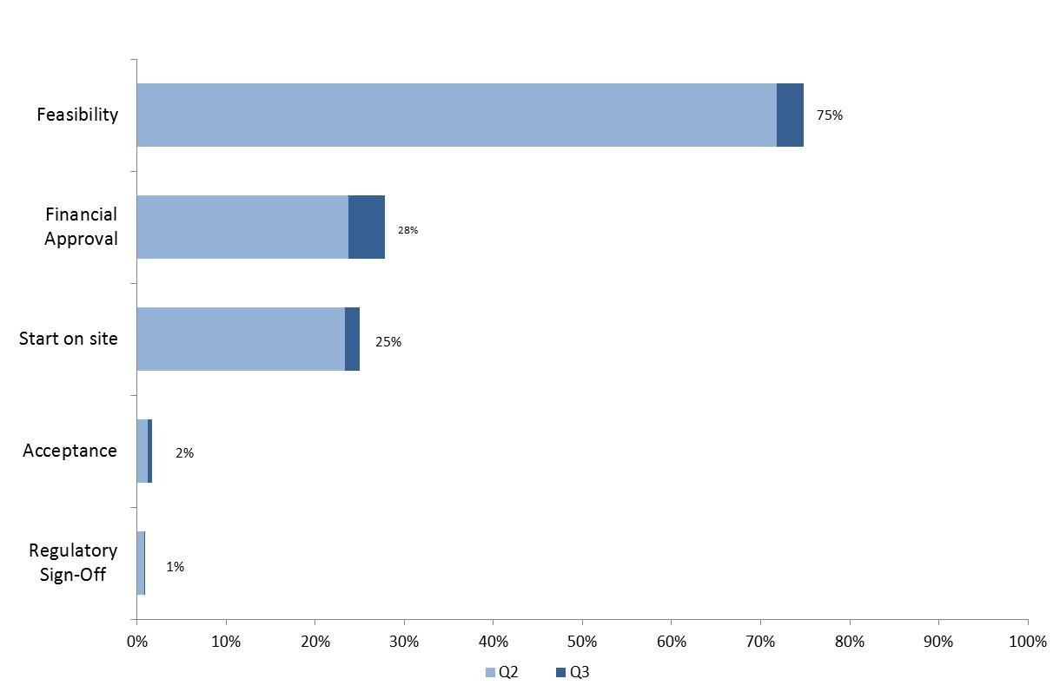

Figure 2 – Reported output programmes - % budget through each milestone

RAG Status
The following colour coding is applied to the forecast in the output delivery tables, using the definitions outlined below:
Red | Progress is behind target and there is no prospect of recovery over the year
Amber | At risk of not delivering the output within the year
Green | On or ahead of programme, or if off track will recover within the year
Blue | Output complete

2. Providing continuous high quality drinking water

Scottish Water is undertaking work associated with the 10 programme areas in the table below.

Objective | Quarterly monitored programme areas | Q2  Actual | Q3  Actual | Year end  target | Forecast year end  status | Total number of outputs over the regulatory period
Drinking water quality and reliability | Number of water treatment works improved | No outputs are planned to achieve  regulatory acceptance in 2015/16 |  |  |  | 28
 | Number of zones made compliant with iron & manganese standards |  |  |  |  | 88
 | Number of improvements to reliability of supply (catchments and treatment) |  |  |  |  | 47
 | Number of improvements to reliability of supply (networks and storage) |  |  |  |  | 82
 | Distribution mains cleaned (km) |  |  |  |  | 5,928
 | Number of water quality etc studies to inform future periods |  |  |  |  | 341
 | 2010-15 outputs planned to complete in the 2015-21 period | 0 | 1 | 5 | 2 - 3 | 23
Drinking water security of supply | Water supply resilience strategy and improvements made | 0 | 0 | 1 | 1 - 2 | 18
 | Number of zones with improved security of supply (SOSI) | 0 | 1 | 0 | 1 | 11
 | Number of security measures and improvements to the infrastructure of critical reservoirs | 0 | 0 | 3 | 0 - 3 | 689

Programme specific explanations:

2010-15 outputs planned to complete in the 2015-21 period
Scottish Water forecasts that it will deliver 2 to 3 outputs in this programme area by March 2016. Regulatory sign-off for the mains distribution work at Lintrathen was achieved in Quarter 3 and Mannofield South was achieved in February. One further output at Beasdale is forecast for regulatory sign-off by March 2016. The improvement work at Carron Valley, which had sample failures during the 9 month monitoring period, is being investigated and if confirmed will required further remedial work on the network to ensure compliance. The revised forecast date is September 2016. For Daer A, additional work has been identified through sampling and the output has a revised forecast delivery date of November 2016.

Number of security measures and improvements to the infrastructure of critical reservoirs
Scottish Water will improve 689 outputs during the 2015-21 period, addressing additional security measures as required by the Scottish Government’s defined security requirements and improve the infrastructure of 56 critical reservoirs, moving to a more proactive and preventative approach. Scottish Water forecasts that up to 3 outputs to improve the infrastructure at critical reservoirs could be delivered by March 2016.

3. Protecting and enhancing the environment

Scottish Water is undertaking work associated with the 10 programme areas in the table below.

Objective | Quarterly monitored programme areas | Q2  Actual | Q3  Actual | Year end  target | Forecast year end  status | Total number of outputs over the regulatory period
Protecting and enhancing the environment | Number of WWTWs improved to meet UWWTD | 5 | 5 | 0 | 5 - 6 | 22
 | Number of waste water networks improved to meet UWWTD | 0 | 1 | 0 | 3 - 6 | 62
 | Number of improvements required to meet UWWTD - Glasgow completion | 6 | 7 | 36 | 21 - 24 | 94
 | Number of improvements required to meet the Water Framework Directive | 0 | 0 | 0 | 1 | 21
 | Number of revised Bathing Waters Directive studies | No outputs are planned to achieve  regulatory acceptance in 2015/16 |  |  |  | 7
 | Number of environmental studies to inform future periods | 0 | 0 | 1 | 0 – 1 | 131
 | Number of improvements required by the Compliance Assessment Scheme; odour reduction and sludge management | 6 | 6 | 2 | 6 | 37
 | 2010-15 outputs planned to complete in the 2015-21 period | 1 | 1 | 9 | 2 - 7 | 16
Flood risk management | Reservoirs Act: improvements to dams | No outputs are planned to achieve regulatory acceptance in 2015/16 |  |  | 0 – 1 | 45
 | Flood Risk Management Act: models and integrated catchment studies |  |  |  | 0 | 218

[Note the following programme areas are not included in the table and are subject to annual reports on delivery: Development of a national strategy on the Priority Substances Directive; Surface Water Management investigations].

Programme specific explanations:

Number of improvements required to meet UWWTD - Glasgow completion
This programme is significantly behind the Delivery Plan baseline across all milestones. Scottish Water originally planned to deliver 36 outputs in Glasgow, initiated in the 2010-15 period, for completion during 2015-16 and forecasts that regulatory sign off will be achieved at between 21 to 24 outputs by March 2016. This is fewer than the 25 to 29 outputs forecast at Quarter 2 because of uncharted services and unforeseen ground conditions associated with the Govan Road Schemes.

Number of environmental studies to inform future periods
Scottish Water has prioritised studies with a focus on flooding projects to deliver customer benefits, some of which will also inform environmental studies, and to inform as far as possible the 2021–27 planning period.

2010-15 outputs planned to complete in the 2015-21 period
Scottish Water forecasts between 2 to 7 outputs to be delivered by March 2016, which is 2 to 7 outputs fewer than originally planned due to unforeseen weather conditions for monitoring, limited specialist modelling resources and land negotiation issues. The following 5 outputs are complete and are being progressed through the regulatory acceptance process:

- Kirkcaldy bathing water study;
- Abstraction control at Tighnabruaich;
- Loch Eck water treatment works abstraction controls;
- Turriff waste water treatment works; and
- Cromwell Road combined sewer overflow

The following 2 outputs have been delayed until 2016/17:

- The bathing water study at Fisherrow Sands has been delayed until 2016/17 as it is dependent on the Edinburgh Integrated Catchment Study which is forecast to be delivered in 2016/17; and
- The Rivers Ayr and Doon Strategic Study is delayed until 2016/17 due to a number of factors including the availability of specialist marine modelling resources and delays to flow surveys as a result of unfavourable weather conditions. Model verification and bathing water model validation can be complex with multiple modelling runs required to resolve these.

4. Supporting economic development

Scottish Water is undertaking work associated with the 6 programme areas in the table below.

Objective | Quarterly monitored programme areas | Q2 Actual | Q3  Actual | Year end  baseline | Forecast year end  status | Total number of outputs over the regulatory period
Supporting economic development | Number of new connections to households and businesses | 8,188 | 11,999 | 18,218 | demand driven | 56,500
 | Delivery of new waste water capacity for 58,000 people | 0 | 0 | 15,353 | demand driven | 58,000
 | Number of first time non domestic meters installed | 2,520 | 3,263 | 3,000 | demand driven | 18,000
 | Number of wholesale meters | 2,828 | 4,535 | 13,223 | 7,700 | 84,000
Climate change | Number of climate change vulnerability assessments | 0 | 0 | 2 | 0 - 2 | 122
Long term cost of service | Improvements in renewable power and energy efficiency (GWh) | 0.94 | 0.94 | 0 | 0.94 – 1.74 | 25.00

[Note the following programme areas are not included in the table and are subject to annual reports on delivery: Number of developer constructed assets adopted; Relocation of services due to transport infrastructure projects; Customer Contact management and communications; Research and Innovation].

Programme specific explanations:

Number of wholesale meters
Scottish Water assumed in its Delivery Plan that the wholesale metering programme would be delivered evenly over the 6 year period 2015-21. With the contractors in place, Scottish Water now has a clearer view of how it intends to achieve the programme and has revised its delivery profile over the 2015-21 period. It will present this revised profile as part of its Delivery Plan refresh, with 7,700 being the revised year-end target for 2015-16. An element of the programme is demand driven and this element has decreased in comparison to forecast for 2015/16.

Number of climate change vulnerability assessments
This programme contains both the number of vulnerability assessments and monitoring improvements to support climate change mitigation and reduction. Scottish Water will deliver 122 outputs in this programme, with up to 2 outputs forecast by March 2016.

5. Quarterly progress on projects due but not delivered by 31 March 2015

 | Q1  2015/16 | Q2  2015/16 | Q3  2015/16 | Q4  2015/16 | 2016/17 | 2017/18 | 2018/19 | 2019/20 | 2020/21
Planned completion | 8 | 20 | 23 | 28 | 32 | 35 | 37 | 37 | 37
Latest forecast completion range | 4 | 6 | 11 | 21 - 25 | 26 – 29 | 31 – 33 | 33 – 36 | 36 | 37

Scottish Water started the 2015-21 period with 37 projects from the previous programme which were due but not completed by March 2015. Scottish Water has achieved regulatory sign-off for 11 of these projects at the end of Quarter 3, with a further 3 projects to February 2016. While this is significantly fewer than the 23 projects anticipated at the end of December, Scottish Water forecasts that a further 7 to 11 outputs will achieve regulatory sign-off by March 2016, bringing the total projects completed in the year to 21 to 25. Scottish Water remains focussed on delivering the projects due to have been completed by March 2015.

6. Conclusion

The OMG notes the progress being made and that at this early stage in the investment period a number of programme areas, including in the Glasgow programme, are behind schedule. It has provided additional material on the progress of specific programmes areas to Ministers as requested.

The OMG has worked with Scottish Water to review all programme delivery dates to ensure that they reflect the latest understanding of the scope of work required, the delivery arrangements that are now fully in place and the latest information on programme risks. Regulators have challenged the dates put forward to ensure that improvements are delivered in line with customer and regulator expectations. The OMG notes that Scottish Water will propose the revised delivery profile as part of its Delivery Plan update to Ministers. The profile that Ministers approve will form the basis of future monitoring and reporting.

Glossary of Terms

Assets | Physical plant and equipment used to produce and transfer water, to collect and treat waste water such as water treatment works and water mains, sewers and sewage works etc.
Climate Change Adaption and Mitigation | ‘Adaptation’ is the action taken by Scottish Water to increase the resilience of its assets to climate change variability and extremes whereas ‘mitigation’ is the steps to permanently eliminate or reduce its carbon emissions associated with its activities.
Delivery Plan | Scottish Water’s annual statement of investment outputs and financial targets.
DMA | District meter areas (DMA) help to identify any localised leakage by the installation of online flow monitors.
Intervention Definition Process (IDP) | Scottish Water’s process to identify scope options and select preferred option to achieve the outcome required.
IR18 | Rolling Investment Review 2018 to consider priorities and outputs for the 2018-21 period and beyond.
Leakage | The water lost from Scottish Water’s network of water pipes and its assets (service reservoirs etc.) between putting water into supply and it arriving at customer taps.
Ministerial Objectives | A statement of requirements (deliverables) set out by Scottish Ministers.
Outputs | Tangible deliverables, such as an improved waste water treatment facility, which benefit customers, the environment or both.
Output Monitoring Group (OMG) | Representatives of Scotland’s water industry who are accountable for the monitoring the progress of output delivery.
Overall Measure of Delivery (OMD) | The metric used to assess Scottish Water’s delivery of its investment-related outputs.
Overall Performance Assessment (OPA) Score | A comparative overview of company performance which is calculated each year. It covers measures of water supply, sewerage service, customer service and environmental performance.
UID | Unsatisfactory Intermittent Discharges. An overflow on the sewer network that requires to be improved so as to meet environmental standards for the water body into which it discharges or which it affects.
UWWTD | The Urban Waste Water Treatment Directive is a European Union directive concerning the "collection, treatment and discharge of urban waste water and the treatment and discharge of waste water from certain industrial sectors".
WWTW | A waste water treatment works (WWTW) treats waste water before returning it to the environment.

21 points relate to outputs that will be confirmed in IR18.
The OMD range has been updated to reflect the Quarter 3 Technical Expression changes.

